**Environment Setup**

**IBM Cloud Account Creation**

|  |  |
| --- | --- |
| Docker Account CreationTeam ID | PNT2022TMID02912 |
| Project Name | Nutrition Assistant Application |

JAI SREE A

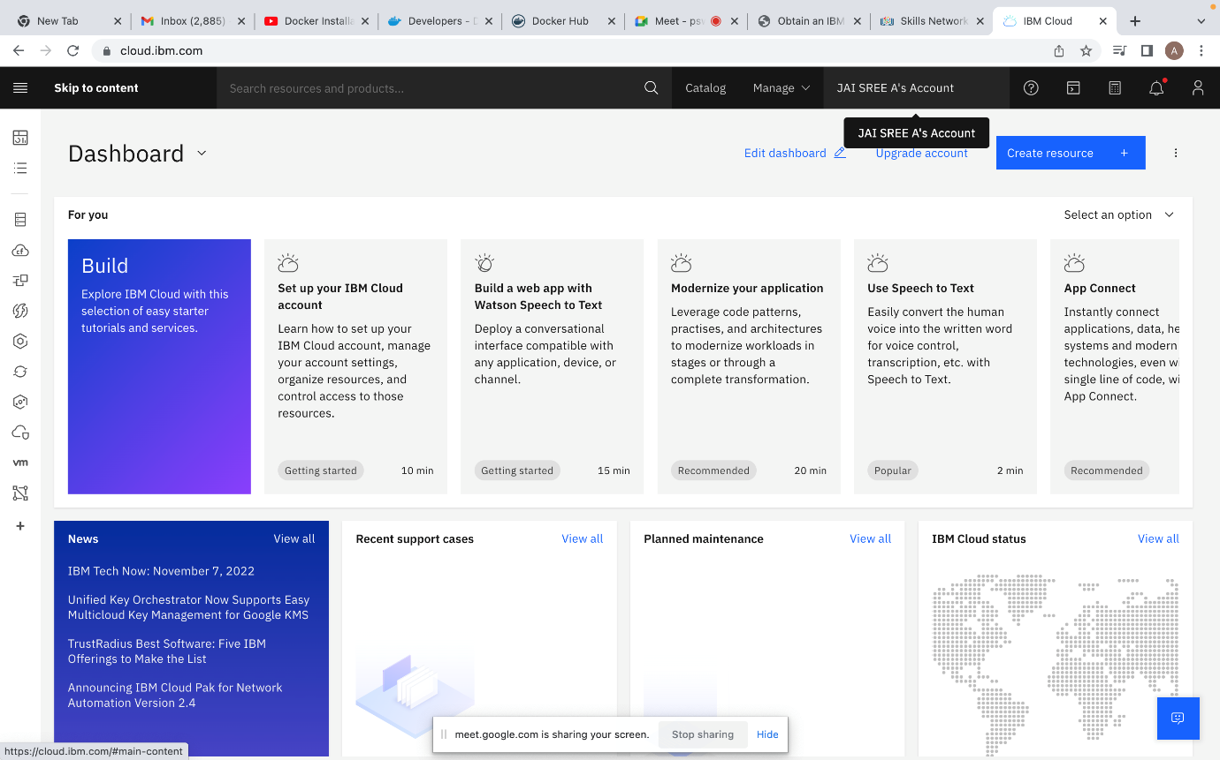

ILAKKIYA G

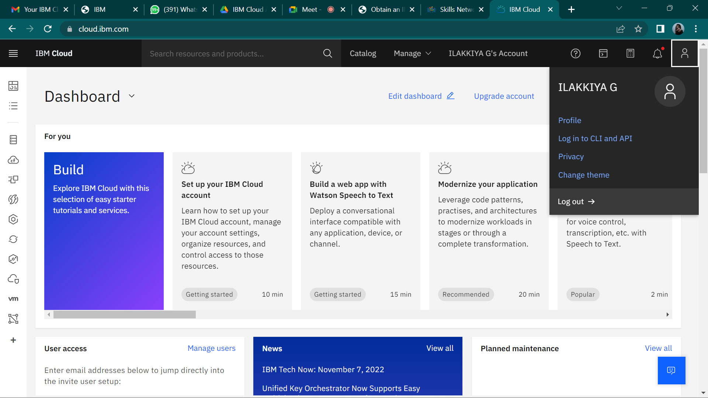

HARIHARAN G

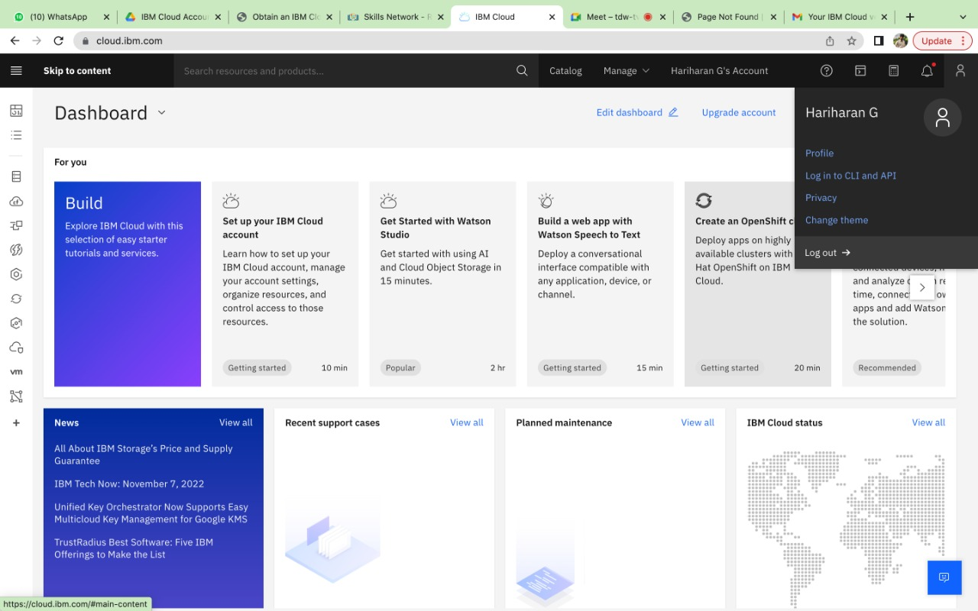

ANKIT KUMAR MAURYA R

